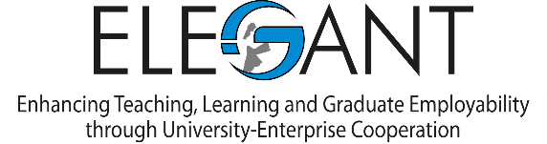

Enhancing Teaching, Learning and Graduate Employability through University-Enterprise Cooperation (ELEGANT)

Annual Planning and Monitoring Meeting

22-23 November 2021
Universita Politecnica delle Marche, Ancona

AGENDA

Day 1: 22 November 2021

9.30-9.45 Welcome and introduction of participants
Prof Giuseppe Canullo, Universita Politecnica Delle Marche
Prof Nebojsa Stojcic, University of Dubrovnik

9.45-11.00 Overall review of project activities
Prof Nebojsa Stojcic; Prof Iraj Hashi, University of Dubrovnik

11.00-11.30 (Coffee )

11.30-13.00 Introducing Mrs Jenny Herbert, External Evaluator of the Project
Reports from partner institutions on the progress of the progject
PSUT - Mr Yazan Abuyaghi/Prof Walid Salameh
JUST - Prof Fahmi Abu Al Rub
ABAU - Prof Tareq Alazab
MUBS - Prof Bassem Kaissi
BAU - Prof Sobhi Abou Chahine
INT@J - Mr Ayad Al Ashram
SCSL- Dr Joumana Dargham
SU - Prof Abdel Hamid Soliman
UNICPM - Prof Giuseppe Canullo
Psicoglobal - Dr Marina Ventura

13.00-14.30 Lunch

14.30-16.00 Discussion of the Intermediate Report of the Project and Steering Committee’s Response

19.00 Dinner

Day 2: 23 November

9.30-13.00 Revised dissemination strategy and project visibility
Plan of Activities for 3rd year of the project
Prof Nebojsa Stojcic; Prof Iraj Hashi, University of Dubrovnik and other
(Coffee participants
11.00-11.30)
- Extension of the project by one year
- WP1 (MOUs, software development)
- WP2 (Work of the Liaison Office; additional seminars)
- WP3 (Curriculum Development)

13.00-14.30 Lunch

14.30-16.00 Other outstanding issues
- Equipment
- Financial issues

